PAS User Manual
author(s) : Angus Chen
document number : PAS User Manual
version : 2.0
source : Atos Origin China
status :
document date : 28 February 2005
number of pages : 56
owner : initials:

© Copyright 2005, Atos Origin China All rights reserved. Reproduction in whole or in parts is prohibited without the written consent of the copyright owner. For any questions or remarks on this document, please contact Atos Origin China, (86)21-63541616*5438.
Contents
1 Introduction 4
2 Time Sheet 5
2.1 Time Sheet Entry 6
2.2 Time Sheet Forecast 8
2.3 Time Sheet Approval 9
2.4 Time Sheet CAF Update 10
3 Project Management 12
3.1 Project Cost Forecast To Complete Monthly 12
3.2 Project Resource Assignment 14
4 Expense 16
4.1 Expense Entry 17
4.2 Expense Verify 18
4.3 Expense Approval 20
4.4 Expense Pay-Out 21
5 Other Cost Entry 22
6 Procurement / Subcontract 23
7 Reporting 24
7.1 Cost By Project Manager 25
7.2 Cost vs. Budget 26
7.3Forecast Variance 27
7.4Project Status 28
7.5Expense Analysis 29
7.6Utilization Report 30
7.7Project Cost 31
8Fiscal Calendar 32
9Master Date Module 33
9.1Project 33
9.2Finance and Accounting (F&A) 35
9.2Finance and Accounting (F&A) 35
9.2.1Exchange Rate 35
9.2.2Cost Rate 35
9.3Customer 36
10 Project Settings 38
10.1Customer Industry 38
10.2Fiscal Calendar 38
10.3Expense Type 39
10.4Project Event 39

List of changes
version | date | description | author

Introduction
In order to ensure the financial health of the project and to achieve the financial objectives originally defined for the project, the Project Accounting System is introduced. It offers complete tracking facilities to help track and manage the cost / expense issues of the project during its delivery life cycle.

Due to some problems with viewing the calendar in the system while having Online Web Browsing Assistant Software installed on PC (like 3721 Assistant), the user is strongly urged to remove or switch off this kind of Assistant Software when using this system.

With PAS, the following functions will be implemented:
- Time Sheet
  - Time sheet entry
  - Time sheet forecast
  - Time sheet approval
  - Time sheet CAF update
- Project Management
- Project cost forecast to complete monthly
- Project member assignment
- Expense
  - Expense entry
  - Expense verify
  - Expense approval
  - Expense pay-out
- Other cost entry
- Procurement / Subcontract
- Fiscal Calendar
- Reporting
- Cost By Project Manager
- Cost vs. Budget
- Forecast Variance
- Project Status
- Expense Analysis
- Utilization
- Project Cost

Also the Master Data and some Project Settings are introduced as well.

Time Sheet

This subsystem allows the project team members to record time spent in pre-defined categories of project related and non-project related tasks. The time spent on a given project are used to calculate project cost when used together with project expenses, procurement and subcontractor costs provides financial view (profit/loss) of the project. Time recorded by project team members requires project manager approval before it becomes valid in PAS.

It has four options which as shown in the diagram 2-1.
- Time Sheet Entry
- Time Sheet Forecast
- Time Sheet Approval
- Time Sheet CAF Update

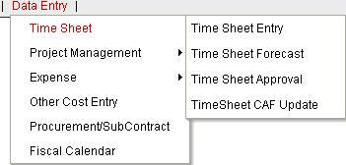
Diagram 2-1

Time Sheet Entry

This section offers a time sheet data table for user to maintain or update the time allocation. It pops up a configuration screen (diagram 2.1-1) for user to specify who is going to maintain the time sheet records.

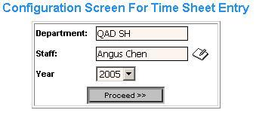
Diagram 2.1-1

Fields definition:
- Department: corresponding with login user’s department by default. If login user is Project Manager or who has certain accessing permission, he/she may choose the department or sub-department belongs to him/her or within permission;
- Staff: list of staff name under selected department. The notepad symbol next to the “staff” square only shows when the login user has certain accessing permission. It allows to specify the user rather than the login user;
- Year: for what year user would like to maintain the time sheet data;

Once the “proceed” button is clicked, a time sheet data table for specified user will be showed as shown in diagram 2.1-2. It shows the list of all weeks for the current year, including time period, total hours maintained, and last updated information. It shows “NA” for total hours by default.
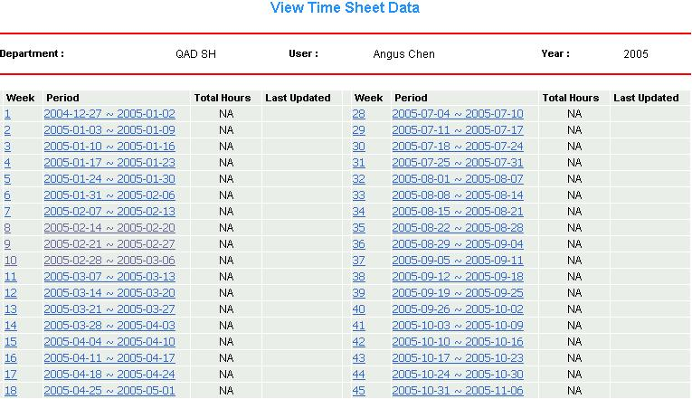
Diagram 1.1-2
User now could specify the week or time period to maintain time sheet date.
Suppose now I want to maintain my time sheet from Feb 7th 2005 to Feb 13th 2005 and during this time period, there is no any time records maintained, the window will show as in diagram 2.1-3.
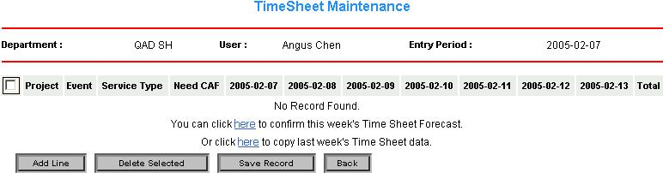
Diagram 2.1-3

Click “Add Line” button, a new window shown as diagram 2.1-4 prompts the user to
- Select proper project from the list which user will allocate time on. The user can only see the project lists under three situations:
  - Those which are set “Open to All” in the department same as user’s;
  - Those in which the login user is the project member;
  - Those which status is “WIP” (working In Process);
- Select proper event from list, which is user’s acting role during working project. Those events are predefined in the system;
- Select proper service type, which is predefined in the project.

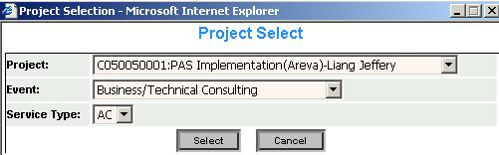
Diagram 2.1-4

Now I could enter my time sheet data in the following screen as shown in diagram 2.1-5.
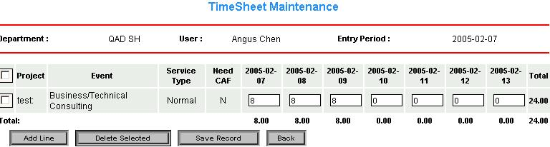
Diagram 2.1-5
Fields Definition:
- “Need CAF” field is to identify if the selected project needs CAF from customer or not. If yes, Project Assistant will need to verify CAF later to ensure the confirmed working hours for staffs;
- User may click “Add Line” button to add another project and maintain the time sheet data in this week;
- User may select the proper project by ticking the check box in the first column, and click the “Delete Button” to delete the selected project;
- Once user entered or updated the time sheet figure, user needs to click “Save Record” button to save what have entered.

System Logic for Time Sheet Entry:
- When the user begins to maintain the time sheet data for a new week, system will prompt the user no-result information, as there is no corresponding data (refer to diagram 2.1-3). The no-result information looks like “No Record Found. You can click here to fetch this week’s forecast data definition or click here to fetch last week time sheet record. User may take following ways to maintain time sheet data for this week.
  - Manually create the time sheet data by clicking “Add Line” button;
  - Or click link provided to get forecasted time sheet data for this week;
  - Or click link provided to get maintained time sheet data for last week;
- Once the user has done the time sheet data maintenance work, user may save the work by clicking “Save Record” button and user may also choose to modify the saved work until it is approved by the project manager.
- User is not allowed to modify the maintained time sheet records any more after being approved by project manager;
- Project Manager may check all employee’s time sheet data who belong to this project manager’s department and sub-department;
- Employees may only maintain their own time sheet data;

Time Sheet Forecast

It is suggested that all employees need to maintain the time sheet forecast in order for Project Managers and Resource Manager to track and manage human resources. This subsystem allows the staffs to entry their future job arrangement. Normally 4 weeks of project assignment will be needed.
Same as time sheet entry, it pops up the configuration screen to specify who is going to forecast the time sheet records (diagram 2.2-1).
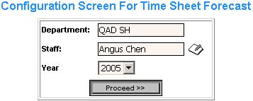
Diagram 2.2-1

The steps for staffs to maintain their time sheet forecasts are same as steps for maintaining time sheet. Please refer to Time Sheet on how to fill Time Sheet Forecast.

System Logic for Time Sheet Forecast:
- User may only forecast the time sheet records from next week, cannot forecast the figure for the current week;
- Project Manager may check all employee’s forecasted time sheet data who belong to this project manager’s department and sub-department for the specified time period;
- Employees may only check their own forecasted time sheet data for the specified time period;
- The over-date forecasted time sheet data can only be checked and cannot be modified any more;

Time Sheet Approval
On the end of every week, Project Manager needs to check and approve the project members’ time sheet records in order to ensure the authenticity and validity of time sheet records. And they need complete this job at least before the fiscal month close.
The users. with special access permission, can click the notepad symbol to specify which project manager (Diagram 2.3-1).
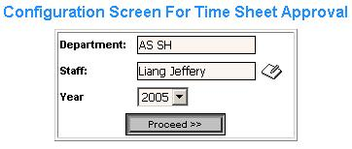
Diagram 2.3-1
After clicking the “Proceed” button, the time sheet records table screen shows all the time sheet records for this specified staff as shown in diagram 2.3-2.
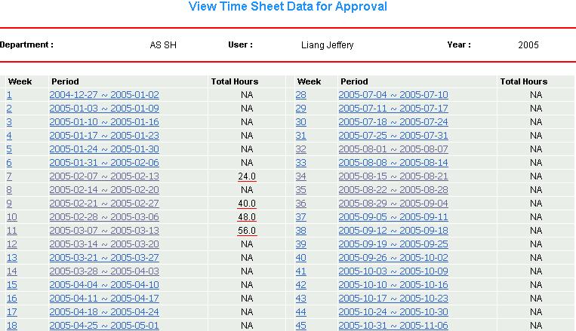
Diagram 2.3-2
To approve proper time sheet record, project manager needs to select the time period with actual total hours figure. Suppose now we want to approve the time sheet records from 2005-03-14 ~2005-03-20, click that time period link, and the time sheet approval screen shows as in diagram 2.3-3.
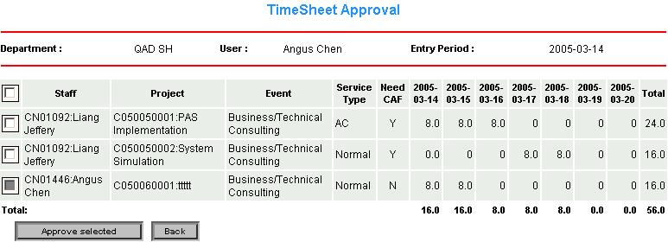
Diagram 2.3-3

Project manager simply ticks the check box in the first column for the corresponding project and click “Approve Selected” button as shown in diagram 2.3-4.
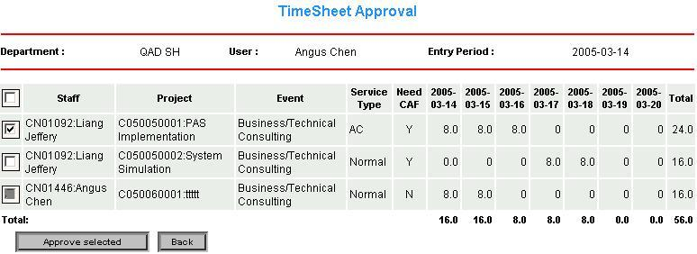
Diagram 2.3-4

System Logic for Time Sheet Approval:
- All actions must be done before the fiscal month is closed. If the submitted time sheet record is not approved after the fiscal month closed, the cost will not be put into the analysis report for that fiscal month, and the time sheet record will be seen as invalid data;
- The approved time sheet records cannot be changed again. As shown from above diagrams, the tick box for the project C050060001 is inactive, which means the time sheet records for this project has been approved, and cannot be approved again;
- No one else can modify or delete the approved time sheet records;

Time Sheet CAF Update

Project Assistant could also update the CAF if needed with proper CAF paper provided by customer. Once CAF is updated, it will be approved automatically.
Same as the other time sheet functions, it will pop up a configuration window to specify the staff whose time sheet records will be checked and verified by project assistant (Diagram 2.4-1).
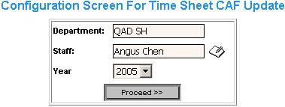
Diagram 2.4-1

Then, Project Assistant just needs to change the number of hours with proper CAF and click the CAF tick box as diagram 2.4-2 shows.
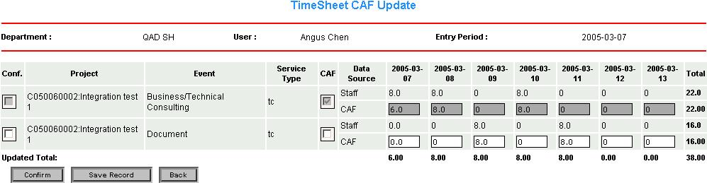
Diagram 2.4-2

System Logic for Time Sheet CAF Update
- Project Assistant with proper CAF may only check particular employee’s time sheet records and cannot modify the time sheet data maintained by this particular employee;
- All of CAF information should be maintained by Project Assistant;
- Project Assistant may still modify the time sheet CAF after clicking the “Save Record” button until the “Confirmed” button is being clicked;
- Once the updated CAF information is confirmed, it cannot be modified any more. As diagram 2.4-2 shows, the record for the confirmed project with c050060002 becomes inactive;

Project Management

This subsystem allows Project Managers to update the project cost monthly in order to complete per project on time and within budgets. It is helpful for manager to understand how much cost will still need to be invested in the future. It also allows Project Managers to assign resources to related project, and control who can access the related project.

It has two options which as shown in the diagram 3-1.
- Project cost forecast to complete monthly
- Project Member assignment

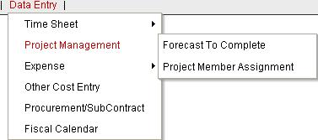
Diagram 3-1

Project Cost Forecast To Complete Monthly

According to the project progress, project manager could know how is project going up to this moment and how much total cost already put into up to this moment. So that project manager could forecast how much cost and how long time still need to complete the project on time and within budgets.

It will prompt the user to select the specified project first as shown in diagram 3.1-1.

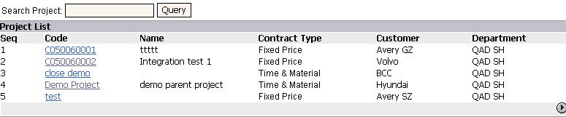
Diagram 3.1-1

Once the proper project is specified, project manager may now check and modify the forecast figure as shown in diagram 3.1-2. After click “Save Record” button, Project manager is still able to update the forecasted cost figure again until fiscal month is closed.

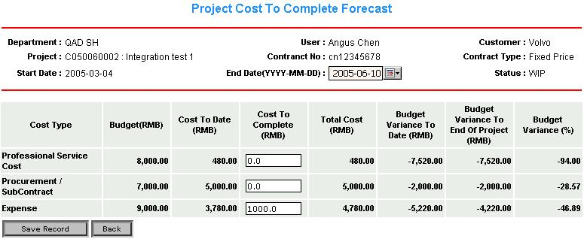
Diagram 3.1-2

Fields definition:
- There are three cost types defined:
  - “Professional Service Cost (PSC)” refers to the approved man-day cost for this project;
  - “Procurement / Subcontract” refers to the confirmed cost registered in Procurement / Subcontract section;
  - “Expense” refers to the approved expense registered by staffs in Expense section;
- The figures in “Budget” field is predefined when create this project;
- “Cost To Date” field refers to the actual approved figure for each cost type before the specified “End Date” in the header;
- “Cost To Complete” field has empty boxes which allows to forecast how much more cost need to complete;
- “Total Cost” field refers the sum of actual approved cost figure (“Cost To Date”) and forecasted figure (“Cost To Complete”);
- “Budget Variance To Date” refers to the difference figure between actual approved cost figure (“Cost To Date”) and “Budget”;
- “Budget Variance To End Of Project” refers to the difference figure between “Total Cost” and “Budget”;
- “Budget Variance (%)” field refers to the figure in “Budget Variance To End Of Project” over the figure in “Budget”;

System Logic for Project Cost To Complete Monthly Forecast:
- Project Manager needs to select proper project and maintain its forecast cost;
- The over-date forecasted cost figure can only be checked and cannot be updated any more;
- All the forecast actions need to be done before the current fiscal month is closed;

Project Member Assignment

In this section, Project manager is allowed to allocate project members to the specified project.

System Logic for Project Resource Assignment:
- Project manager needs to specify the particular project first, which needs to assigned resources on. As diagram 3.1-1 shows, a list of projects will show when the certain conditions are specified such as project code, customer, or department;
- Once the proper project is specified, project may assign the project members in the new window as shown in diagram 3.2-1.
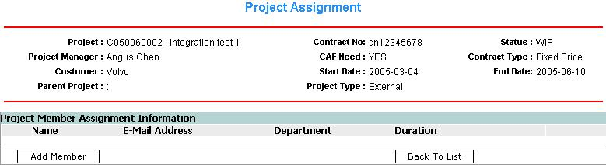
Diagram 3.2-1

- A new window (diagram 3.2-2) will pop up after clicking “Add Member” button. It will prompt the project manager to select:
  - Department: in which the particular project member belongs to;
  - Member: particular project member;
  - Start date: date when to start working;
  - End date: date when to finish working;
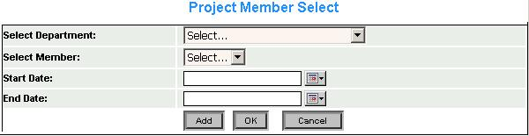
Diagram 3.2-2

- Project manager needs to click “Add” button to assign the specified member and click “OK” button to return to project list page as shown in diagram 3.2-3;
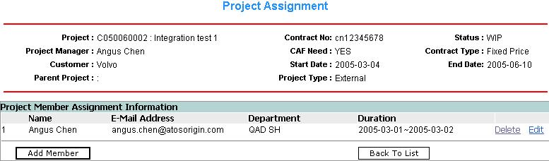
Diagram 3.2-3
Fields Definition:
- Duration field defines the start time and end time for the specified project member to work on the specified project;
- Project manager may delete the assigned project member by clicking “delete” button;
- It is also allowed for project manager to modify the working time period for selected member by clicking the “Edit” button;

Expense

This subsystem allows project team members to register expenses incurred for the existing projects, which are recorded and accumulated per project.

Expense claims operational procedures as shown in the diagram 4-1.
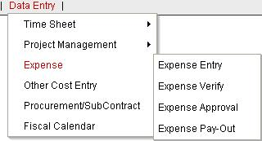
Diagram 4-1

- Expense Entry: user logs in PAS system and maintains expense entry;
- Expense Verify: user maintains the expense sheet and submit to be verified;
- Expense Approval: user needs to submit the expense sheet for project manager or other related person to approve;
- Expense Pay-Out: when finance receives the expense sheet, needs to logs in PAS system and verify the related expenses and maintain claim operation;

The working flow for the expense claiming is shown as in diagram 4-2.

Staff | Project Assistant | Project Manager | Finance & Accounting
Expense Form Entry
Expense Form Verify
Expense Form Post to F&A
Expense Form Approve
Export Data into Sun System
Expense Form Confirm
Diagram 4-2

Expense Entry

Project team member may register expense for selected project in this section.
System Logic for Expense Entry:
- As shown in diagram 4.1-1, before user submits expense form, the status field is set as “Draft”. This is for user to modify the expense form later after submitting but before it gets approved.
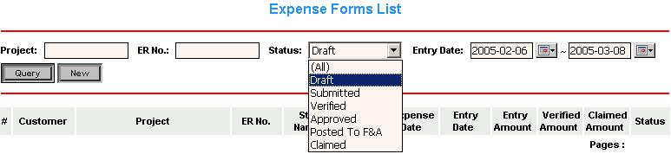
Diagram 4.1-1
- In diagram 4.1-1, by choosing proper status, User may tract the expenses to see whether they are submitted, verified, approved, posted to F&A or claimed. “Posted To F&A” status is to identify the projects which PA has posted to F&A;
- Click “New” button to create a new expense form as diagram 4.1-2.
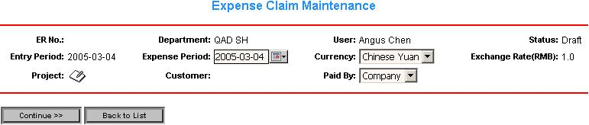
Diagram 4.1-2

- Specify the “Expense Period” first so that lists of working projects are available to choose for the user. Then click the notepad symbol next to the “Project” field to choose the proper project, and set proper conditions such as currency”, “expense period” and “Paid by” then click “Continue>>” button. A new window appears and user may edit the expense as show in diagram 4.1-3.
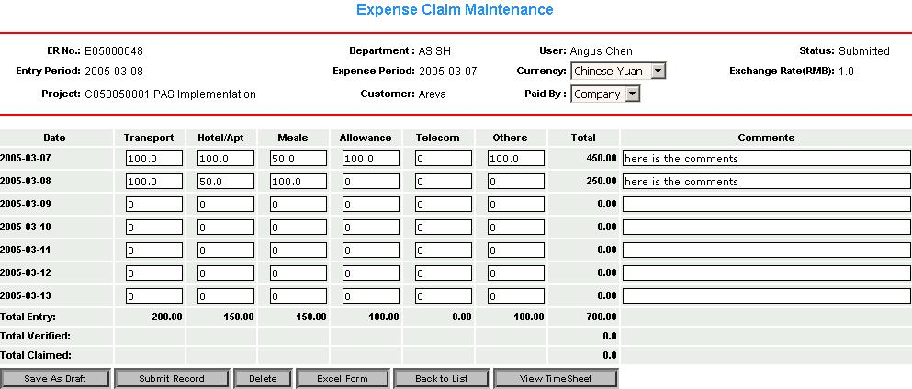
Diagram 4.1-3
- Once finish editing the expense, user can choose to
  - Save this expense form by clicking “Save As Draft” button. User may still modify this form later and this form will be in the list (diagram 4.1-1) with status “Draft”;
  - If there is nothing more to modify and update this expense form, user may click “Submit Record” button to submit for project assistant to verify and for project manager to approve. User is not allowed to submit the empty form. The submitted form cannot be modified any more and this form will be in the list (diagram 4.1-1) with status “submitted”;
  - User may also delete this expense form before submitting it by clicking “Delete” button;
  - User may export this form to Excel file by clicking “Excel Form” button;
  - If user wants to go back to the form list (diagram 4.1-1), click “Back to List” button;
  - If user wants to check the time sheet records, click “View Timesheet” and pop up screen looks like diagram 4.1-4.

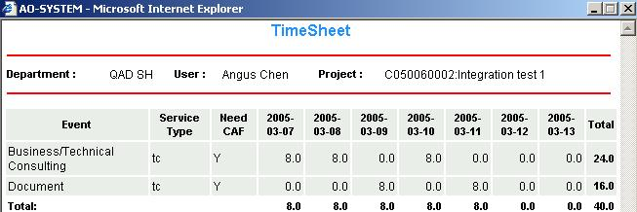
Diagram 4.1-4

Expense Verify

Generally two operations will be implemented by project assistant in this section.
- Verifying the Expense Forms: Project Assistant needs to verify the expense forms, which submitted by staffs before they are getting approved by project manager. Normally the forms with status “Submitted” need to be verified;
- Posting the Expense Forms to F&A: Project Assistant needs to query the expense forms which approved by project managers, and post them to Finance & Accounting. Normally the forms with status “Approved” need to be posted to F&A.

Verifying the Expense Forms

Once user submits the expense form, it needs to be verified by Project Assistant or who else related to make it ready for project manager to approve later as shown in diagram 4.2-1.

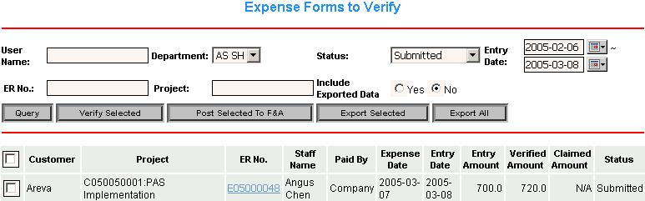
Diagram 4.2-1

Fields definition:
- Project assistant may verify the specific expense form by tick the check box corresponding with the specified expense form and click “Verify Selected” button. If PA wants to verify all the forms, just tick the top check box;
- Project assistant may export the specific expense to excel file by tick the check box corresponding with the specified expense form and click “Export Selected” button. If PA wants to export all the forms, just click “Export All” button;
- “Include Exported Data” identifies which expense forms will be shown in the list. If set “Yes”, all the forms satisfied with conditions include those forms which have exported before will show in the list. If set “No”, all the forms satisfied with conditions exclude those forms which have exported before will show in the list;

Project Assistant may view the expense details by clicking the “ER No.”, as diagram 4.2-2.
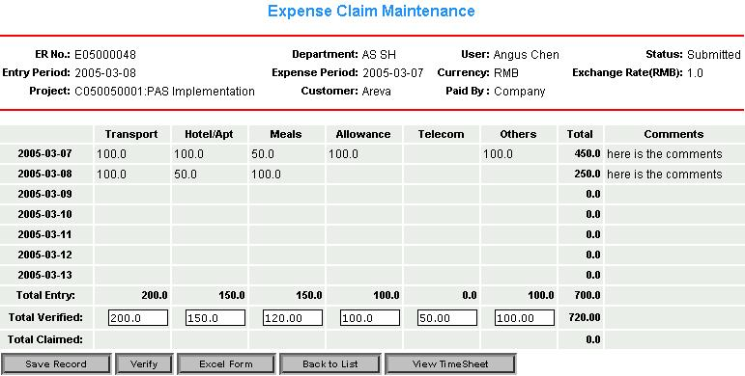
Diagram 4.2-2

Project assistant may modify the figures in the text box corresponding with the “Total Verified” row, and is allowed to
- Save this expense form by clicking “Save Record” button. PA may still modify this form later;
- If there is nothing more to modify and update this expense form, PA may click “Verify” button to post it for project manager to approve.;
- PA may export this form to Excel file by clicking “Excel Form” button;
- If PA wants to go back to the form list (diagram 4.2-1), click “Back to List” button;
- If PA wants to check the time sheet records, click “View Timesheet” and pop up screen looks like diagram 4.1-4.

Posting the Expense Forms to F&A

Once the expense forms have been approved by project managers, the project assistant can query these approved forms with selecting the “Approved” status as shown in diagram 4.2-3.
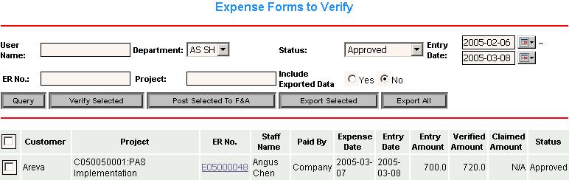
Diagram 4.2-3

Project assistant may post the approved expense form to F&A by tick the check box corresponding with the approved expense form and click “Post Selected To F&A” button. PA also can view the expense details by clicking the “ER No.”, as diagram 4.2-4.
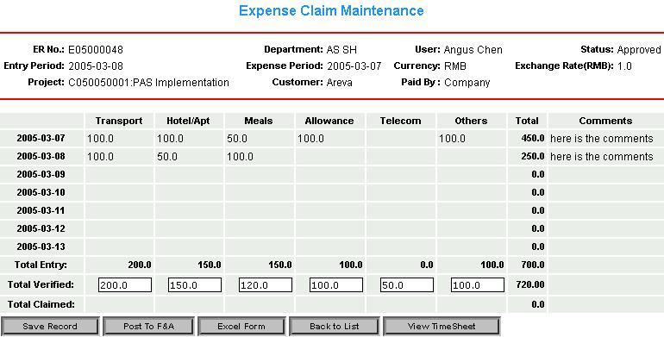
Diagram 4.2-4
From diagram 4.2-4, PA may still modify the figures in the textbox for the “Total Verified” field until this form is getting claimed. If this is an approved expense form, PA is able to see the “Post To F&A” button rather than “Verify” button. If PA wants to post this form to F&A, just click this button.

Expense Approval

Once project assistant verifies the expense form, it needs to be approved by Project Manager in this section so that it can be claimed later from finance as shown in diagram 4.3-1.
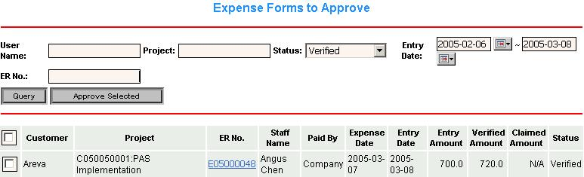
Diagram 4.3-1

Project manager may verify the specific expense form by tick the check box corresponding with the specified expense form and click “Approve Selected” button. If PM wants to approve all the forms, just tick the top check box;

Project Manager may view the expense details by clicking the “ER No.”, as diagram 4.3-2.
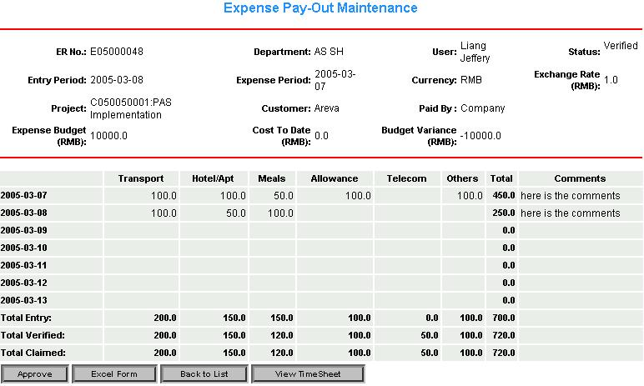
Diagram 4.3-2
Project manager is allowed to
- Approve this expense form by clicking “Approve” button. Once the expense form is approved, it cannot be modified any more;
- PM may export this form to Excel file by clicking “Excel Form” button;
- If PM wants to go back to the form list (diagram 4.3-1), click “Back to List” button;
- If PM wants to check the time sheet records, click “View Timesheet” and pop up screen looks like diagram 4.1-4.

Expense Pay-Out

Once the expense form is approved and posted to finance, now it can to be claimed in this section as shown in diagram 4.4-1.
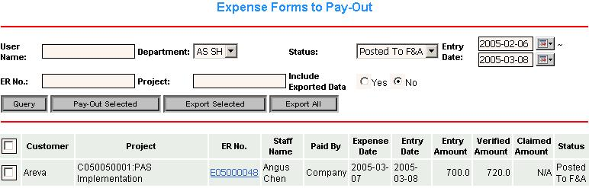
Diagram 4.4-1
Finance staff may pay out the specific expense form by tick the check box corresponding with the specified expense form and click “Pay-Out Selected” button. If finance staff wants to pay out all the forms, just tick the top check box;

Finance staff may view the expense details by clicking the “ER No.”, as diagram 4.4-2.
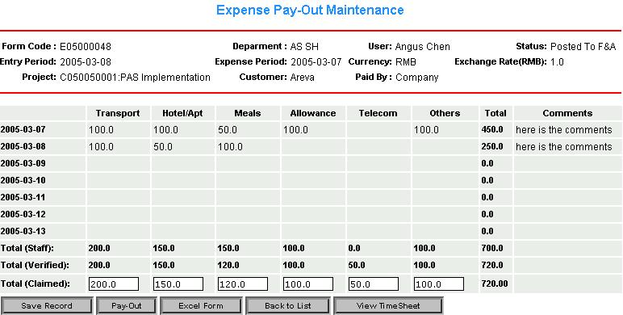
Diagram 4.4-2
Finance staff may modify the figures in the text box corresponding with the “Total (Claimed)” row, and is allowed to
- Save this expense form by clicking “Save Record” button. Finance staff may still modify this form later;
- If there is nothing more to modify and update this expense form, finance staff may click “Pay-Out” button. Once the form is clamed, the figure cannot be modified any more.
- Finance staff may export this form to Excel file by clicking “Excel Form” button;
- If Finance staff wants to go back to the form list (diagram 4.4-1), click “Back to List” button;
- If Finance staff wants to check the time sheet records, click “View Timesheet” and pop up screen looks like diagram 4.1-4.

Other Cost Entry

Due to some expenses are not included in expense claiming such as Airfare Expense, housing Expense and Other Expense, the specified Project Assistant will maintain them into the system. PA may specify the “type”, “cost date” and “department” to query the result (diagram 5-1).

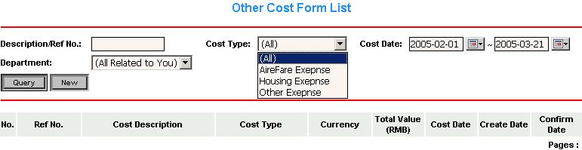
Diagram 5-1

PA may also create a new cost sheet for selected project by simply clicking “New” button. In order to save and confirm this form, Project Assistant needs to specify the necessary information as shown in diagram 5-2.

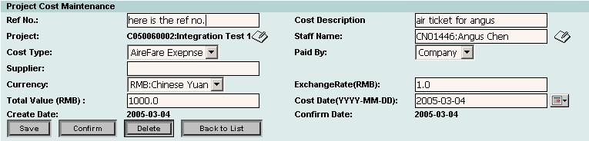
Diagram 5-2

Project assistant is allowed to
- Save this expense form by clicking “Save” button. PA may still modify this form later;
- If there is nothing more to modify and update this expense form, PA may click “Confirm” button so that this cost will be counted in and this confirmed form cannot be modified any more;
- PA may delete this form before getting confirmed by clicking “delete” button;
- If PA wants to go back to the form list (diagram 5-1), click “Back to List” button;

Procurement / Subcontract

This section is for specified Project Assistant to entry and confirm procurement / subcontract expenses for projects such as Hardware Procurement, Other Procurement, Subcontract Procurement and Software Procurement. PA may specify the “type”, “cost date” and “department” to query the result (diagram 6-1).

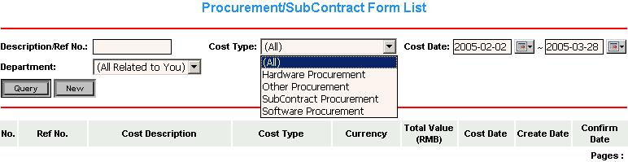
Diagram 6.1

PA may also create a new cost sheet for selected project by simply clicking “New” button. In order to save and confirm this form, Project Assistant needs to specify the necessary information as shown in diagram 6-2.

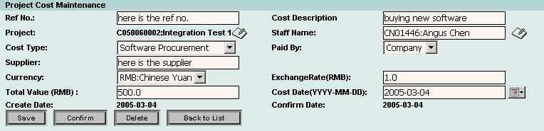
Diagram 6-2

Project assistant is allowed to
- Save this expense form by clicking “Save” button. PA may still modify this form later;
- If there is nothing more to modify and update this expense form, PA may click “Confirm” button so that this cost will be counted in and this confirmed form cannot be modified any more;
- PA may delete this form before getting confirmed by clicking “delete” button;
- If PA wants to go back to the form list (diagram 6-1), click “Back to List” button;

Reporting

PAS also has a function for user to query and generate proper reports, which is Report subsystem as shown in diagram 7-1.

There are 7 different reports available:
- Cost By Project Manager
- Cost vs. Budget
- Forecast Variance
- Project Status
- Expense Analysis
- Utilization Report
- Project Cost Query
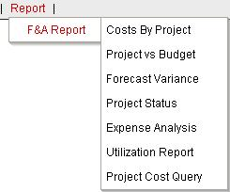
Diagram 7-1

Cost By Project Manager

This section records the costs by project manager.
System logic for Cost by Project manager Report
- User needs to specify the date range and department in which to get specific figure;
- The query result may be exported to excel file by clicking “Export to Excel” button;

Refer to project “Integration Test 1”, in which “Angus Chen” is the project manager, who belongs to “QAD SH” department (diagram 7.1-1).
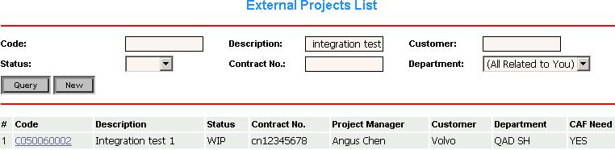
Diagram 7.1-1

Now suppose that we’d like to query the cost by “Angus Chen”. We need to specify the “department” to “QAD SH”, and click “Query”.
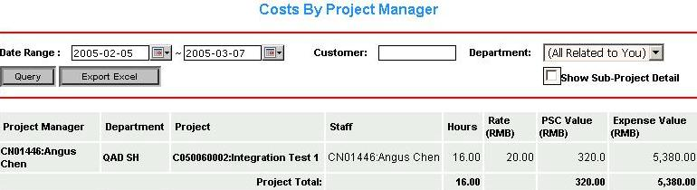
Diagram 7.1-2

Result shows in diagram 7.1-2, “Angus Chen” has 16 hours in project “Integration Test 1” with Rate 20.00 RMB, to get PSC 320.00 RMB (hours * rate) and expense 5,380.00 RMB. User may export the result to excel file by clicking “Export Excel” button.
“Show Sub-Project Detail” is to identify if the user wants the cost report for the sub-project if this project has one or many sub-projects.

Cost vs. Budget

This section produces the cost and budget figure report for a specified project. Project manager and finance could find out project progress status from viewing this report.

System logic for Cost vs. Budget Report
- Project manager or finance need to specify the fiscal month and department in which to get specific cost and budget figure;
- The query result may be exported to excel file by clicking “Export to Excel” button;

Fields definition for Coat vs. Budget Report (diagram 7.2-1):
- “Sales Value (Service)” is the total service value of the project;
- “Total Budget” is the sum of PSC (professional service value) budget and expense budget of the project;
- “Total Costs This Month” is the value of total approved cost figure for the specified fiscal month;
- “Total Costs To Date” is the value of total approved cost figure since the foundation of the project;
- “Forecast to Completion” is the sum of PSC (professional service value) forecast and expense forecast of the project;
- “Budget Variance To Date” is the difference between “Total Costs To Date” and “Total Budget”;
- “Budget Variance To End of Project” is the difference between the total cost to complete (sum of “Total Costs To Date” and “Forecast to Completion”) and “Total Budget”;
- “% Comp” is the completed percentage which is “Total Costs To Date” over total cost to complete (sum of “Total Costs To Date” and “Forecast to Completion”);
- “Forecasted % Over Budget” is “Budget Variance To End of Project” over “Total Budget”;
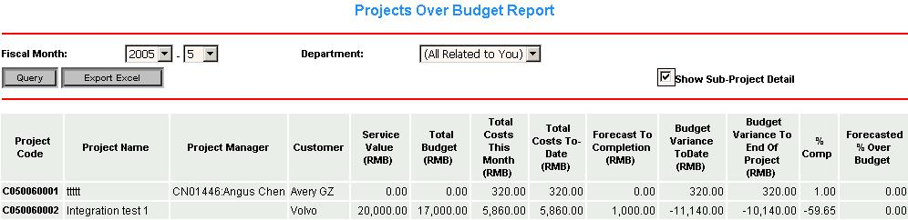

Diagram 7.2-1

Forecast Variance

In this section, Project Managers and finance may specify the fiscal month in order to track the cost and revenue (lost/profit) for each fiscal month. Hers is an example.
It is defined in “fiscal calendar, fiscal month 5 actually starts from 2005-02-07 to 2005-05-29 as shown in diagram 7.3-1 with red underline.
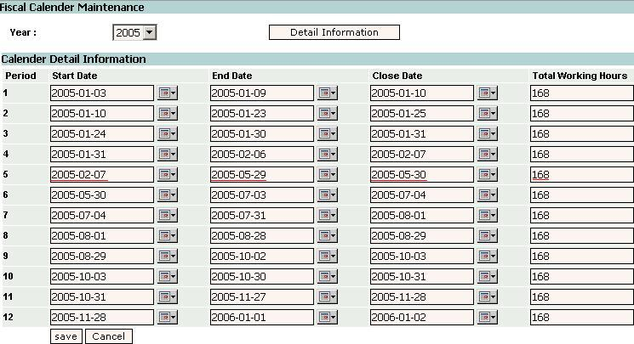
Diagram 7.3-1

So we set “fiscal month” to 5 in Revenue Forecast Variance Report, as shown in diagram 7.3-2 and click “Query” button.
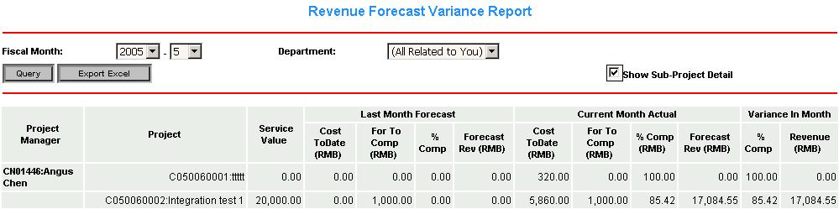
Diagram 7.3-2

Field definitions for Revenue Forecast Variance Report:
- “Service Value” is the “total service value” when create a new project;
- “Last Month Forecast” is the forecast for last fiscal month;
- “Cost ToDate” refers to the total cost up to date for this project;
- “For To Comp” refers to forecast to complete. The value of this field is defined in “Project Cost to Complete monthly Forecast” of “Project Management” subsystem;
- “% Comp” refers to complete percentage, which equals to “Cost ToDate” / (“Cost ToDate” + “For To Comp”);
- “Forecast Rev” refers to forecast revenue, which equals to “Service Value” * “% Comp”;

Now finance and Project Managers may compare last forecast fiscal month with current actual fiscal month to get variance in month.

Project Status

This section produces the cost, budget and project profitability figure report for a specified project. Project manager and finance could find out project progress status from viewing this report (diagram 7.4-1).
System logic for Project Status Report
- Project manager or finance need to specify the fiscal month and department in which to get specific cost, budget and project profitability figure;
- The query result may be exported to excel file by clicking “Export to Excel” button;
Fields definition:
- “Total Sales Value” is the sum of total service value and total procurement / subcontract value of the project;
- “Service Value” is the total service value of the project;
- “Budget” is the sum of PSC (professional service value) budget and expense budget of the project;
- “Projected Cost Last Month” is the value of total approved cost figure from the foundation to last fiscal month of the project;
- “Projected Cost Current” is the value of total approved cost figure since the foundation of the project;
- “Completion Last Month” is the completed percentage of last fiscal which is “Projected Cost Last Month” over total cost to complete Last Month (sum of “Projected Cost Last Month” and “Forecast to Completion Last Month”);
- “Completion Current” is the completed percentage which is “Projected Cost Current” over total cost to complete (sum of “Projected Cost Current” and “Forecast to Completion”);
- “Budget Variance” is the difference between “Projected Cost Current” and “Budget”;
- “Budget Variance%” is the percentage which is “Budget Variance” over “Budget”;
- “Project Profitability Planned” is the difference between “Total Sales Value”(sum of total service value and total procurement / subcontract value) and “Budget”;
- “Project Profitability Planned%” is the percentage which is “Project Profitability Planned” over “Total Sales Value”(sum of total service value and total procurement / subcontract value);
- “Project Profitability Actual” is the difference between “Total Sales Value”(sum of total service value and total procurement / subcontract value) and “Projected Cost Current”
- “Project Profitability Actual%” is the percentage which is “Project Profitability Actual” over “Total Sales Value”(sum of total service value and total procurement / subcontract value);
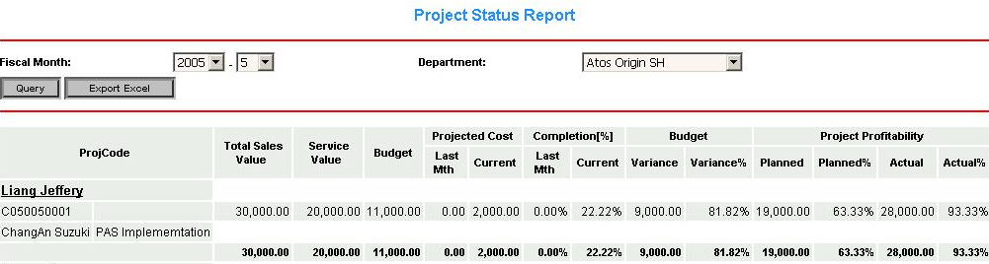Diagram 7.4-1

Expense Analysis

This section produces the expense detail figure report for a specified project. Project manager and finance could find out project expense from viewing this report (diagram 7.5-1).

System logic for Expense Analysis report
- Project manager or finance need to specify the fiscal month and department in which to get specific expense figure;
- The query result may be exported to excel file by clicking “Export to Excel” button;

Fields definition:
- “Claim Value” is the value of expense;

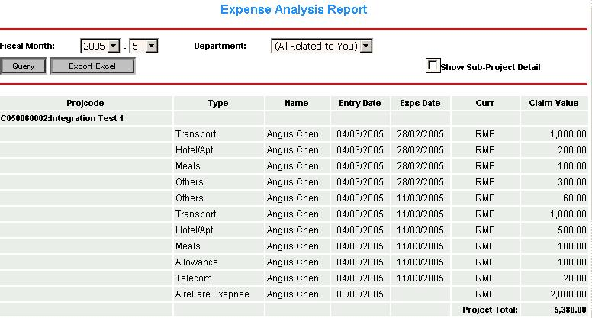
Diagram 7.5-1

Utilization Report

This section is for Project Managers to get the Utilization Report so that Project Managers may better control the resource.
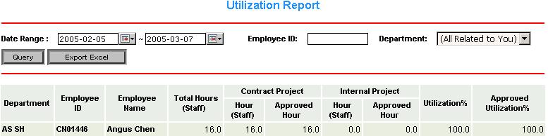
Diagram 7.6-1

User needs to specify the date, employee ID, or department to query the result (diagram 7.6-1).
System logic
- Project manager or finance need to specify the date range, employee ID and department in which to get specific time sheet summary figure;
- The query result may be exported to excel file by clicking “Export to Excel” button;

Field definition:
- “Total Hours (staff)” refers to the total hours for the specified staff during the date range;
- “Utilization %” equals total contract hours / total hours;
- “Approved Utilization %” equals total approved hours / total hours;

Project Cost

This section produces the cost and budget figure report for a specified project. Project manager and finance could find out project progress status from viewing this report (diagram 7.7-1).
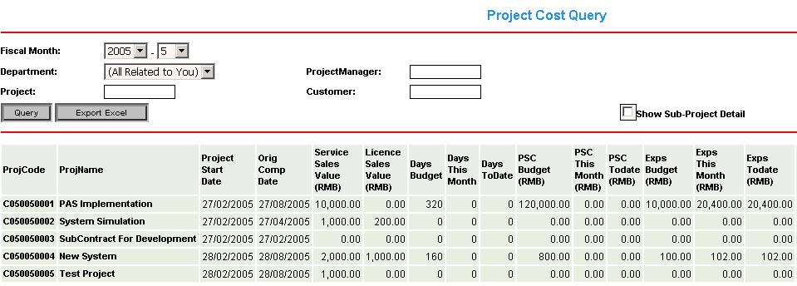
Diagram 7.7-1
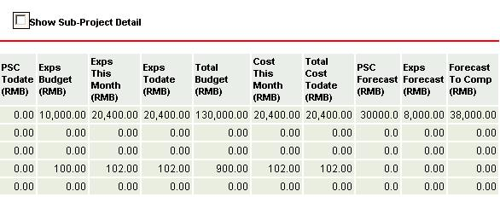
Diagram 7.7-1

System logic for Project Cost report
- Project manager or finance or project or department or customer need to specify the fiscal month and department in which to get specific Project Cost figure;
- The query result may be exported to excel file by clicking “Export to Excel” button;

Fields definition:
- “Service Sales Value” is the total service value of the project;
- “Days Budget” is the total man days budget of the project;
- “Days This Month” is the value of total man days for the specified fiscal month;
- “Days Todate” is the value of total man days since the foundation of the project to the end of the specified fiscal month;
- “PSC Budget” is the value of PSC(professional service value) budget of the project;
- “PSC This Month” is the value of total PSC for the specified fiscal month;
- “PSC Todate” is the value of total PSC since the foundation of the project to the end of the specified fiscal month;
- “Exps Budget” is the value of expense budget of the project;
- “Exps This Month” is the value of total expense for the specified fiscal month;
- “Exps Todate” is the value of total expense since the foundation of the project to the end of the specified fiscal month;
- “Total Budget” is the sum of PSC (professional service value) budget and expense budget of the project;
- “Cost This Month” is the value of total approved cost figure for the specified fiscal month;
- “Cost To Date” is the value of total approved cost figure since the foundation of the project;
- “PSC Forecast” is the PSC forecast of the project;
- “Exps Forecast” is the expense of the project;
- “Forecast to Com” is the sum of PSC (professional service value) forecast and expense forecast of the project;

Fiscal Calendar
This function is provided for users in order to check the fiscal month information at any time. The fiscal calendar is defined by finance department every year and looks like diagram 8-1.

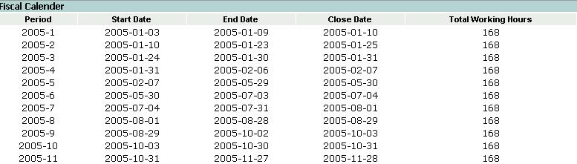

Diagram 8-1

Master Date Module
Master Data module defines the project types, Finance and Accounting information (F&A), and customer information. With this well-defined module, thus, system administrator is able to not only create, modify, and close the project but also manage the project costs.
This section is mainly maintained by finance department.

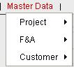
Diagram 9-1

Project

As showed in diagram 9.1-1, two project types are defined:
- External Project;
- Internal Project;
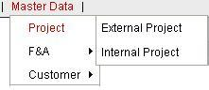
Diagram 9.1-1
System logic for project:
- Notice that once the project has been created, it cannot be deleted, it can only be cancelled;
- If the project is closed/canceled, any timesheet/expense/other related cost would not be allocated for this project;

External Project

This section is for billable service project. User could search the desired project from the existing project list with proper conditions (diagram9.1.1-1). User can also create a new contract project by clicking “new” button.
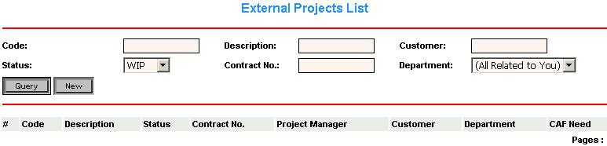
Diagram 9.1.1-1

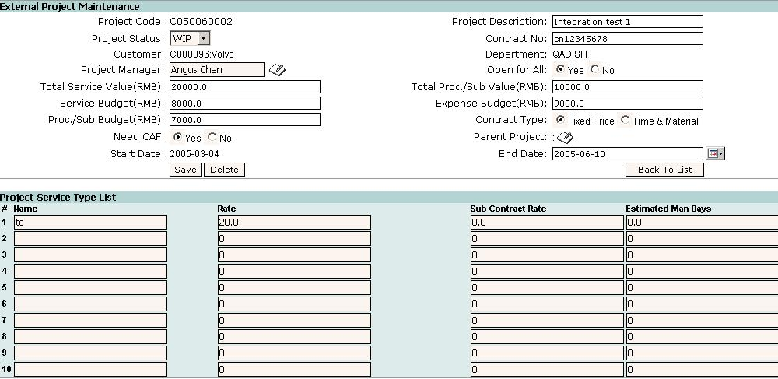
Diagram 9.1.1-2
Fields definition for Contract Project (diagram 9.1.1-2):
- Project code is created by sequence number or entered by user;
- Select “WIP” in status option for creation;
- Leave contract number blank for presale;
- If it is a new customer, needs to create new customer profile;
- Need to select the project manager and department;
- “Open for All” options are set to identify if this project is public or not. If it is “Yes”, project manager doesn’t need to assign member on it and all staffs under this department or sub-department could access this project to maintain his or her own time sheet records. If it is “No”, means this project is not public for all staffs. Project Manager needs to assign project members on it and only project members can access this project to maintain necessary information;
- Total Service Value is the value for total service cost;
- Total Proc./Sub Value is the value for total Procurement and Subcontract cost;
- Service Budget stands for professional service cost budget;
- Two types of contract are defined such as Fixed Price and Time & Material. If Fixed Price is selected, then the total costs of contract project are fixed with in a certain time. Time & Material options means the total costs of contract project are updated with time and material expanding.
- Need CAF, identify if the project need CAF, if the set the option as “Yes”, then PA need update related Time Sheet CAF status with this project;
- In the “Project Service Type List” window:
  - Name refers to the service type such as normal, AC for application consultant and TC for technical consultant;
  - Rate and subcontract rate are predefined in the system for project member’s working hour rate;
  - Estimated man day refers to the estimated working days for project members;

Internal Project

This section is for non-billable service project, which mainly works inside the company or overhead activity like Training or Annual Leave.

The operational procedures for internal project is almost same as the external project except:
- Once create the internal project, please specify the department so that the other department may not see this project;
- “Open for All” options are set to identify if this project is public or not. If it is “Yes”, project manager doesn’t need to assign member on it and all staffs under this department or sub-department could access this project to maintain his or her own time sheet records. If it is “No”, means this project is not public for all staffs. Project Manager needs to assign project members on it and only project members can access this project to maintain necessary information;

Please refer to the external project for the operational procedures of internal projects.

Finance and Accounting (F&A)
Some cost factors need to be considered when track the project costs such as (diagram 6.2-1)
- Exchange Rate
- Cost rate;
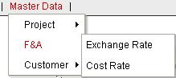
Diagram 9.2-1

Exchange Rate
This section is for finance staffs to define currency type and exchange rate to RMB. (diagram 9.2.1-1)
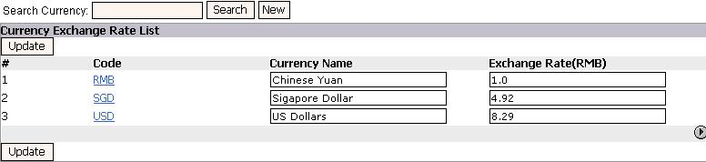
Diagram 9.2.1-1

Cost Rate
This section is to update the staffs’ cost rate in this year. It needs to select the proper department and specify the year before locate the particular staff as shown in diagram 8.3-1
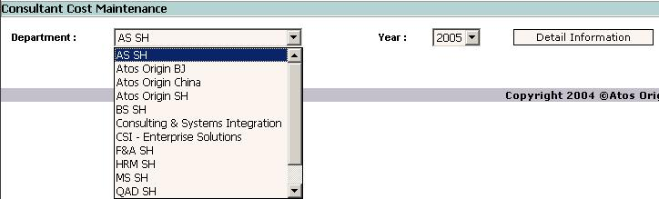
Diagram 9.2.2-1
Then edit and save the cost rate for the particular staff as shown in diagram 9.2.2-2.
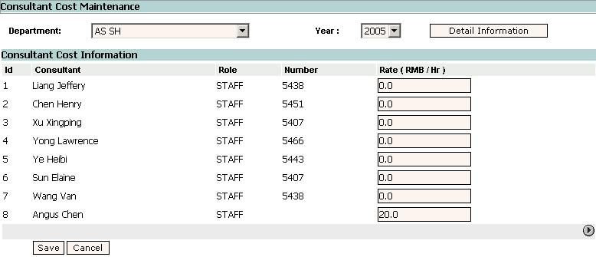
Diagram 9.2.2-2

Customer
In this section (diagram9.3-1), finance staffs could manage the customer information and customer group.
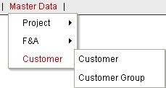
Diagram9.3-1

Customer
As diagram 9.3.1-1 shows, all the customer information should be managed in this section. If there is no such a customer information in this list, finance staff needs to create a new customer by click “New” button. Also finance staffs need to specify the each of customer to the proper industry and group.
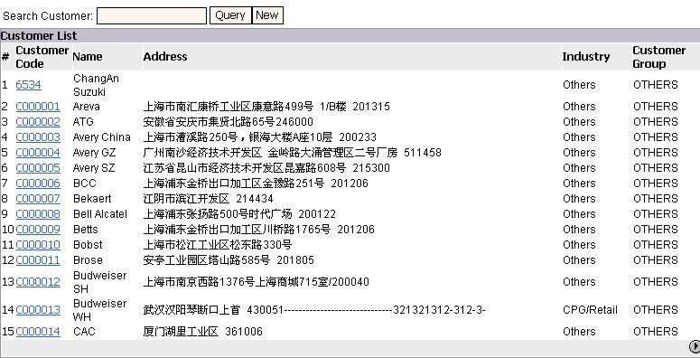
Diagram9.3.1-1

Customer Group
As diagram 9.3.2-1 shows, all the customer group information should be managed in this section. If there is no such a customer group information in this list, finance staff needs to create a new customer group by click “New” button.
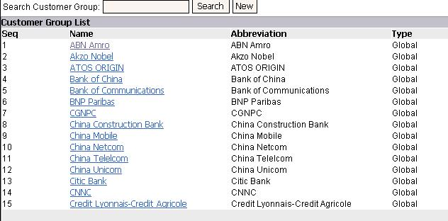
Diagram9.3.2-1

Project Settings
There are some settings need to be predefined for the project such as customer industry, fiscal calendar, expense type and project event (diagram 10-1).
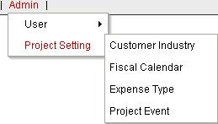
Diagram 10-1

Customer Industry
Customer industry is defined as shown in diagram 10.1-1.
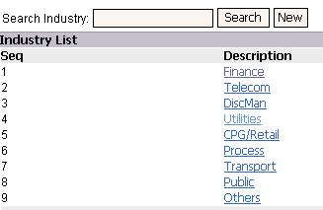
Diagram 10.1-1

Fiscal Calendar
In this section, finance staffs may maintain the fiscal month information for the year as shown in diagram 10.2-1.
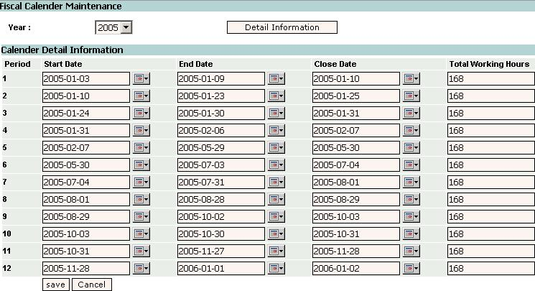
Diagram 10.2-1

Expense Type

This section is to define the expense account type in the expense claim entry functional module.(diagram 10.3-1)
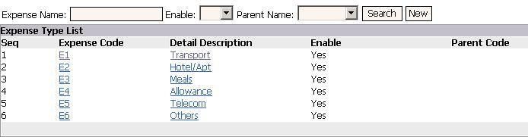
Diagram 10.3-1

Project Event
This section defines the acting roles for different event category. User can select proper event when edit the time sheet. (diagram 10.4-1)
Fields definition for Event Category:
- Billable defines if this event is billable or not;
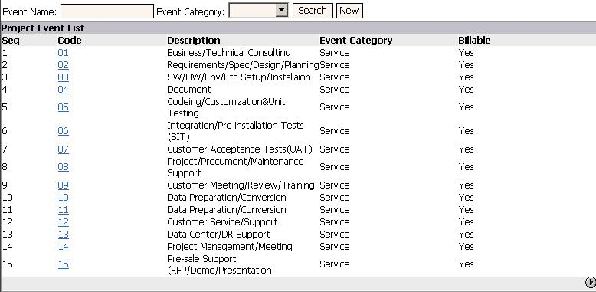
Diagram 10.4-1

